Understanding Student Success in a Student-Centered University
Student success, student engagement, student development and retention are often used interchangeably when discussing a student-centered environment. This document attempts to define these terms and their usage in the strategic planning processes.
Penn State Worthington Scranton has demonstrated its support of a student-centered environment by putting a number of initiatives in place and by exceeding the fundraising goals of the latest campaign entitled, “For the Future: A Campaign for Penn State Students.”
The planning foundations of the 2008-2015 Penn State Worthington Scranton Strategic Plan incorporated aspects of creating a student-centered community under the guiding principles for Building a Sense of Community. In order to become more student-centered, both the institution and the students must be aware of what constitutes a student-centeredness. At Penn State Worthington Scranton, student-centered means focusing on the needs of the students and fostering their success.
Much work has already been done at Penn State Worthington Scranton to bring institutional focus on the needs of the students and the opportunities to promote student success in a holistic manner.
Background
- In 1998, a student support services committee charged by Dean J. Strasser formed to identify core services students should expect to find at each Commonwealth campus. These services were categorized as essential, priority and desirable. Over the last fifteen years, modest changes have occurred, reflecting students’ changing needs. (Appendix A)
- In 2004, the University established a central enrollment management group and developed an enrollment management plan, including goals for both recruitment and retention.
- In 2005, the campus implemented an enrollment management plan focusing on the three key areas of marketing, recruiting, and retention. Recruiting and marketing have developed strongly around the activities of the Enrollment Management Council, the Marketing Council, the E-team (Electronic Presence Team) and other task forces. Retention is critical and needs focus and clarity.
- In 2008 and 2011, the campus participated in the NSSE Survey (National Survey of Student Engagement). Categories assessed were academic challenge, active learning, student/faculty interaction, supportive campus environment. Other surveys reviewed were the 2007/2010 Student Satisfaction Survey and the 2010 Orientation survey. From the surveys, it was determined that the structured co-curricular learning opportunities had decreased.
This led the campus to begin the development of a co-curricular program.
- In 2011, The David and Ann Hawk Student Success Center was established for the purpose of housing all key student programs and services in an integrated and inclusive area specifically designed to provide students with direct and convenient access to those services and the professionals providing them.
- In 2011, the Core Council recommended the development of strategies to improve year-to-year student retention rates to 80% in the next three years, which is a goal for all Commonwealth Campuses. Worthington Scranton’s one-year retention rate for the fall 2010 first-time, full-time baccalaureate cohort was 69%, below the median for comparably-sized campuses (76%).
The Core Council recommended the study of Worthington Scranton graduation rates to determine the reasons for relatively lower graduation rates and higher than average time-to-degree and to develop strategies to improve six-year graduation rates for students remaining at Worthington Scranton.
- In 2013, a Campus Strategic Marketing and Engagement Plan was developed and is currently under review and in the initial stages of implementation.
Defining Student Success
(source: http://trocklin.wordpress.com/2009/10/22/definitions-matter/)
Students succeed when they achieve personal and institutional educational goals. Successful students develop skills and knowledge, become more mature in their thinking, assume greater responsibility for their own lives and learning, develop understanding of diversity and multiculturalism, and become effective leaders.

Student and institutional success is measured by examining a variety of indicators, including measures of learning, persistence, graduation, engagement, health and well-being, and job placement.

Metrics for measuring student success include the following.

- Retention rate
- Graduation rate
- Improved GPA
- Internship summary reports
- Effective integration with school community through cocurricular activities
- Full time employment / post graduate activities
Retention
Retention is a measure of student success that needs focus and clarity. Retention can be defined as the "ability of an institution to retain a student from admission through graduation" (Seidman, 2005, p. 14).
Penn State chooses to measure retention by comparing student enrollment from the fall of their freshman year to the fall of their sophomore year and with institutional 6 year graduation rates.
Retention rates are reported in the Penn State Fact Book at: http://www.budget.psu.edu/factbook/
The core council recommends that Penn State Worthington Scranton have a fall to fall retention rate of 80% for first-time, full-time baccalaureate cohort and a six year graduation rate of 60%.
To improve the retention of students at Penn State Worthington Scranton, our retention plan and focus will be to infuse the existing essential services with student engagement principles, as we will demonstrate later in this document.
An engaged student is a retained student.
Measures of Student Success and Student Engagement
Retention Rate
As defined by Penn State: The percent of a given cohort that remains enrolled at Penn State. A cohort is defined as the first-time, full-time, degree-seeking freshmen that enter in a given fall. The number of those students who are still enrolled in subsequent fall semesters are counted and divided by the cohort size to determine the retention rate for each year.
Cohort Population is first-time degree seeking baccalaureate freshmen.
A retention rate spreadsheet detailing the last ten years of data is kept by the Registrar’s Office and updated annually after Fall Census date. The data are reviewed annually.
Data Source: Penn State Fact Book (http://www.budget.psu.edu/factbook/StudentDynamic/StudentTableOfContents.aspx )
Path: Student, Retention Rates
Reported annually by the Director of Enrollment Management (DEM) at the Fall Enrollment Management Council (EMC)
Graduation Rate
The percent of a given cohort that graduated within a specified amount of time is the graduation rate. A cohort is defined as the first-time, full-time, degree-seeking freshmen that enter in a given fall. The number of students who graduate before the fall semester four, five and six years later is counted and divided by the cohort size to determine the graduation rate for each of those years. The rates are cumulative, so students who graduated within four years are also included in the five-year rate.
Rates include students who began in a baccalaureate degree and graduated with a bachelor’s degree.
Cohort Population is first-time degree seeking baccalaureate freshmen. Penn State does not track students when they transfer to another institution. The graduation rates do not reflect students who may have continued at another school to successfully complete their degree.
Change of Assignment – “Two plus Two” are student who choose University Park as their first choice but start at a commonwealth campus
A graduation rate spreadsheet showing the last ten years of data is maintained by the Registrar’s Office and updated annually. Data are reviewed annually.
Data Source: Penn State Fact Book (http://www.budget.psu.edu/factbook/StudentDynamic/StudentTableOfContents.aspx )
Path: Student, Graduation Rates
Reported annually by the Director of Enrollment Management (DEM) at the Fall Enrollment Management Council (EMC)
Grade Point Average (GPA)
An indication of a student's academic achievement, calculated as the total number of grade points received over a given period.
A GPA spreadsheet showing the last ten years of data is maintained by the Registrar’s Office and updated annually. Data are reviewed annually.
Data Source: ITwo Student Enrollment Dashboard
Internship Summary Reports
List of companies providing paid and unpaid internships in each program area
Summary of Midpoint and Final Student Evaluations from Employers
Internship summary data for the last ten years is maintained by Career Services and is updated each semester an internship program in run.
Data Source: surveys from Internship Coordinators
Reported by Internship Coordinators
Effective integration with school community through cocurricular activities
Worthington Scranton is currently investigating the implementation of an online co-curricular transcript.
Reports:
Reported by: Director of Student Affairs
Co-curricular summary data for the last ten years is maintained by each student and submitted to the Career Services Office throughout annual meeting with Career Services.
Post Graduate Activities
Graduates from Worthington Scranton at all levels are surveyed from data provided by the campus Registrar. This includes names of students who were approved to graduate. The data will be gathered from a questionnaire send via email to December, May and August graduates. Surveys will be sent at the time of graduation; non-respondents will be re-surveyed three months after graduation.
Post-Graduation Survey administered by Career Services at University Park

• Highest degree
• Penn State location from which they received their degree
• Academic college and major
• Gender
• Post graduation plans
- If employed full-time, respondents were asked
- The degree to which current employment matched career objectives
(very much, somewhat, very little)
- Annual salary
- Location of employment (by state)
- If pursuing further education, respondents were asked
- Degree sought
- Curriculum and institution

Data Sources: Career Service Post Grad Survey results
http://studentaffairs.psu.edu/career/postgrad.shtml

Worthington Scranton Career Services has also developed an online survey.

Worthington Scranton Post Graduate Survey
http://www.sn.psu.edu/StudentServices/26552.htm

Post Graduate summary data for the last ten years is maintained by Career Services and is updated annually.

Additional Metrics

- In targeted areas and academic programs, there are additional indicators of success.
- Number of students enrolled in remedial courses and the number/percentage that are successful (C or better) in those courses
- Course withdrawal (percent of enrollments that resulted in a “W.”)
- Graduates, 6 months out: percent employed only, attending school only, employed and attending school, neither
- Employment 6 months out: match field of employment with desired field of employment, report % working in desired field
- Attending school 6 months out: degree-seeking master’s, degree-seeking doctoral, degree-seeking professional; certificate-seeking technical; non-degree seeking.
- Percent of students attending graduate school within five years of baccalaureate degree;
- Licensure passage rates in nursing: NCLEX, number examined, number passed, passage rate
- Percent among a graduating class who completed internships while enrolled
- Percent of undergraduates who say they volunteer in community service at the institution, participate in off-campus internships, play intramural or recreational athletics, play intercollegiate athletics, participate in student government
Student Engagement

Student engagement represents both the time and energy students invest in educationally purposeful activities and the effort institutions devote to using effective educational practices
(Kuh, 2001).

Students succeed by active engagement in educationally-purposeful activities.

Faculty, staff, and students create formal and informal learning opportunities in many different learning environments, both on campus and off. Policies, programs, and practices can also foster student engagement. Understanding our student profile is essential building programs that foster student engagement. Thus, it will be and needs to be considered necessary to develop a student profile and educate the campus community regarding students on and off campus commitments.

An engaged student is a retained student.

Both the institution and the student participate in student engagement, with key elements tailored to both the needs of the student and the requirements of the institution. It is not a “student as customer model”, but one that relies on synergies between the institution and the student for success.
Penn State Worthington Scranton Student Engagement Model
Learning Environments
Academic Progress
Student Development
Institution
Student
Financial Support

Learning Environments are defined as the social, psychological, physical and pedagogical contexts in which learning occurs. These dynamic learning environments are both formal and informal and include our buildings and their instructional and social spaces. It also includes virtual environments and the delivery systems used to support online instruction.
Learning Environments
Penn State Worthington Scranton recognized the need to create learning environments that support active and collaborative learning by making group study spaces a priority for the new Business Building which opened in 2009. Additional group study spaces have been developed in the library and the Student Success Center.
The two-phase science suite project was completed in 2010 to provide updated facilities for students in Biology, Physics and Chemistry, offering larger, modern integrated spaces that promote collaborative learning and distance delivery.
An instructional designer was hired in January 2012 to support new delivery systems and innovative pedagogical models for student-centered instruction.
Students provide feedback on learning environments in a number of ways—through SRTE data, online technology survey data, and communicating with their instructors.
Penn State Worthington Scranton is committed to providing responsive design and support of learning environments that promote student success.
New initiatives include:
- Establishing an Instructional Design Center
- Renovating the Library space to be more compatible with the changes in students’ social behaviors, learning styles, and delivery system.

Desired Outcomes:
- Increased enrollment

Financial Support

Financial support is important to student success. Being able to pay for college is a critical factor in retaining our students at Penn State Worthington Scranton. Engaging parents and students early and often to discuss the financial commitment is an initial step on the path to student success.
A number of initiatives have been put into place to assist students and their parents when it comes to paying for college. Penn State Worthington Scranton has exceeded the goal for fundraising in the University’s For the Future, the Campaign for Penn State’s Students. Financial aid workshops are held each January to assist parents in filing the FAFSA forms. A hardship fund has been established for students in need, and Penn State Worthington Scranton offers over 150 scholarships for students based on need and academics.
New Initiatives Include:
- Continued fundraising for endowed scholarships
- Financial Aid Night
- Financial literacy programs for students
- Education of the campus community regarding socioeconomic status and financial aid statistics of our students
Desired Outcomes
- Students and parents will be educated on and engaged with the amount of debt and consequential repayment they are taking on.
- Student loan average debt will be reduced as a result of increased scholarships.

Academic Progress

Academic progress is a measure of students’ academic performance. Successful students make academic progress and the Penn State Worthington Scranton supports their efforts in a number of ways.
The David and Ann Hawk Student Success Center was established in 2011 for the purpose of housing all key student programs and services in an integrated and inclusive area specifically designed to provide students with direct and convenient access to those services and the professionals providing them.
Academic tutoring is available to enable student’s academic progress. A new scheduling system that allows students to manage their own tutoring schedule was installed in 2012.
In 2011, an Advising Center manager was hired to improve advising services for the students. Advisor training has been conducted and an Advising Plan created for continuous quality improvement in this area.
Other services that promote student progress and therefore student success, include disability services for students with learning and physical disabilities.
A digital commons was established in 2005 for students and faculty to enhance their presentation skills through the use of multimedia.
An instructional designer assists faculty in developing timely course materials and incorporating today’s technology into the classroom with project like clickers, Doceri, and lecture capture.
A New Program Task Force has been formed to identify possible new programs in our service area.
New initiatives include:
- Advising Plan
- New program task force to identify additional 4-year majors based on local job market analysis
- New Business Accounting Option, Science Program, Psychology Major and Corporate Communications
Desired Outcomes
- Internships/clinical hours for all students in 4 year degree programs
- Degrees that are in demand in our community

Student Development
Student Development is the ways that a student grows, progresses, or increases his or her developmental capabilities as a result of enrollment in an institution of higher education. (Rodger, 1990)
Activities that support student development can take place inside and outside the classroom. Some examples of student development activities are co-curricular activities, leadership activities, for example student government or club officers, mentoring programs and career programs.
A number of programs have already been established at Penn State Worthington Scranton through the generosity of our donors. These are:
- Linde Family Mentoring program
- Unico Scranton Chapter Program Endowment in Italian Studies
- Timothy L. Arcaro Program for Human Development and Family Studies
- Eric P. Anderson Annual Growing Leaders Student Development Fund
- Richard M. and Jean Walsh Lecture series
- Marcos Family Program Endowment in Information Sciences and Technology
New initiatives include:
- Athletic Field Renovations
- EOP program
- NEPA Leadership certificate program
- Co-curricular transcripts
- Developing a more comprehensive New Student Orientation program

Desired Outcomes
- Student involvement in clubs and organizations will increase from the current rate of ___% to ___%
- Students will be able to use a co-curricular transcript to assist them in marketing themselves during job search and graduate school selection processes.
- ___% of PSWS will complete the NEPA Leadership program

Glossary

Student Success | Student Success – student success in college encompasses academic achievement; engagement in educationally purposeful activities; satisfaction; acquisition of desired knowledge, skills, and competencies; persistence; educational attainment; and post college performance. (Manning, Kinzie, & Schuh, 2006)  "institutional commitment is strengthened when undergraduates are actively engaged in educationally purposeful endeavors that connect them to the campus and in which they feel some sense of enduring obligation and responsibility" (Bean; Swail, Redd & Perna; and Tinto, as cited in Harper & Quaye, 2009, p. 4).
Student Engagement | Student engagement represents both the time and energy students invest in educationally purposeful activities and the effort institutions devote to using effective educational practices  (Kuh, 2001).
Cocurricular | Cocurricular experiences include formal and informal out-of-class learning opportunities. These opportunities include involvement with clubs and organizations, workshops, lectures, internships, co-ops, interactions with faculty and other students, cultural events and study abroad.
Internships | Any official or formal program to provide practical experience for beginners in an occupation or profession.
Retention | Retention can be defined as the "ability of an institution to retain a student from admission through graduation" (Seidman, 2005, p. 14). Penn State chooses to measure retention by comparing student enrollment from the fall of their freshman year to the fall of their sophomore year and with institutional 6 year graduation rates.
Transfer-outs | Students who embark upon their educational careers in one institution and, then, before they complete their goal or obtain their degree, they leave and enroll in another college/university (Bonham and Luckie, 1993). The main reasons for leaving for this group typically include: financial (reflecting not just the issue of ability to pay, but the perception of value of investment), job conflicts, availability of programs/courses, dissatisfaction with the institution, and transfer institution is closer to home (Hoyt and Winn, 2003).
Completion/Graduation | Is the outcome of how many students within a cohort complete and/or graduate from an institution. This is typically measured in two or three years for associate level programs and four, five, or six years for a bachelor level programs. (Noel-Levitz Retention Codifications, 2008)

Appendix A
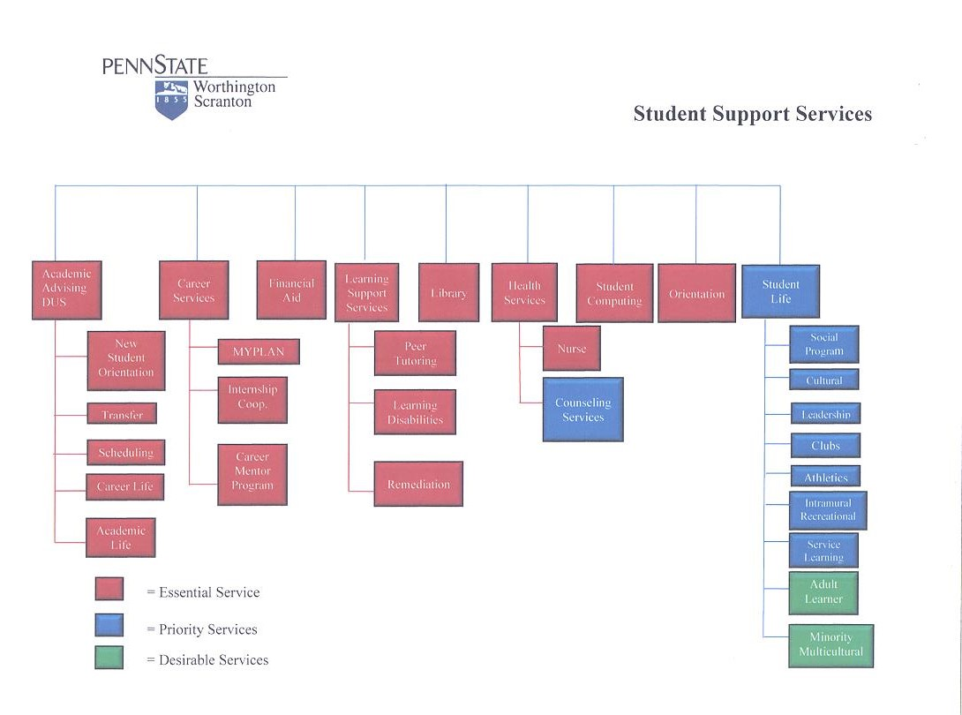

Appendix B

Report | Source | Person Responsible | Date Reported to Chancellor
Graduation Rate | Penn State Fact Book | DEM | Yearly
Retention Rate | Penn State Fact Book | DEM | Yearly
Grade Point Average | I2 Dashboard | Registrar | By Semester
Post Graduate Activities | Career Services Survey (UP)  Career Services Survey (WS) | DSA | Yearly
Number of students enrolled in remedial courses and the number/percentage that are successful (C or better) in those courses | Data Warehouse or I2 Dashboard | Registrar
Course withdrawal (percent of enrollments that resulted in a “W.” | Data Warehouse or I2 Dashboard | Registrar

Appendix C
Additional Resources
Graduate Schools and Program
http://studentaffairs.psu.edu/career/pdf/postgrad/GraduateSchools.pdf
Employers and Job Titles
http://studentaffairs.psu.edu/career/pdf/postgrad/Employers_Job_Titles.pdf

Office of Institutional Planning and Assessment
http://www.psu.edu/president/pia/
Fact Book http://www.budget.psu.edu/factbook
Career Services http://studentaffairs.psu.edu/career/

